

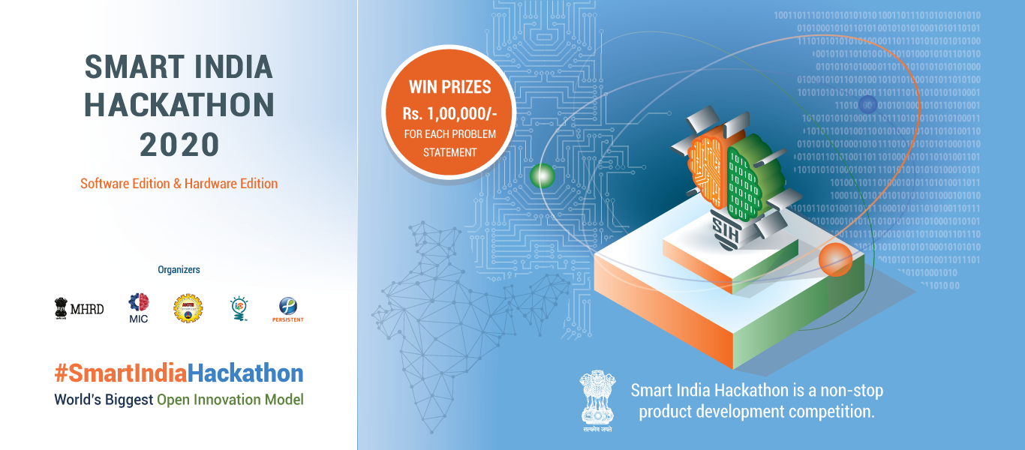



**Ministry Category**

**Problem Statement**

**Team Name :**

**Organization/Ministry :**

**Category : Software/Hardware**

**Technology Bucket :**

**Problem Statement :**

**Team Leader Name**

1 Prototype Sample

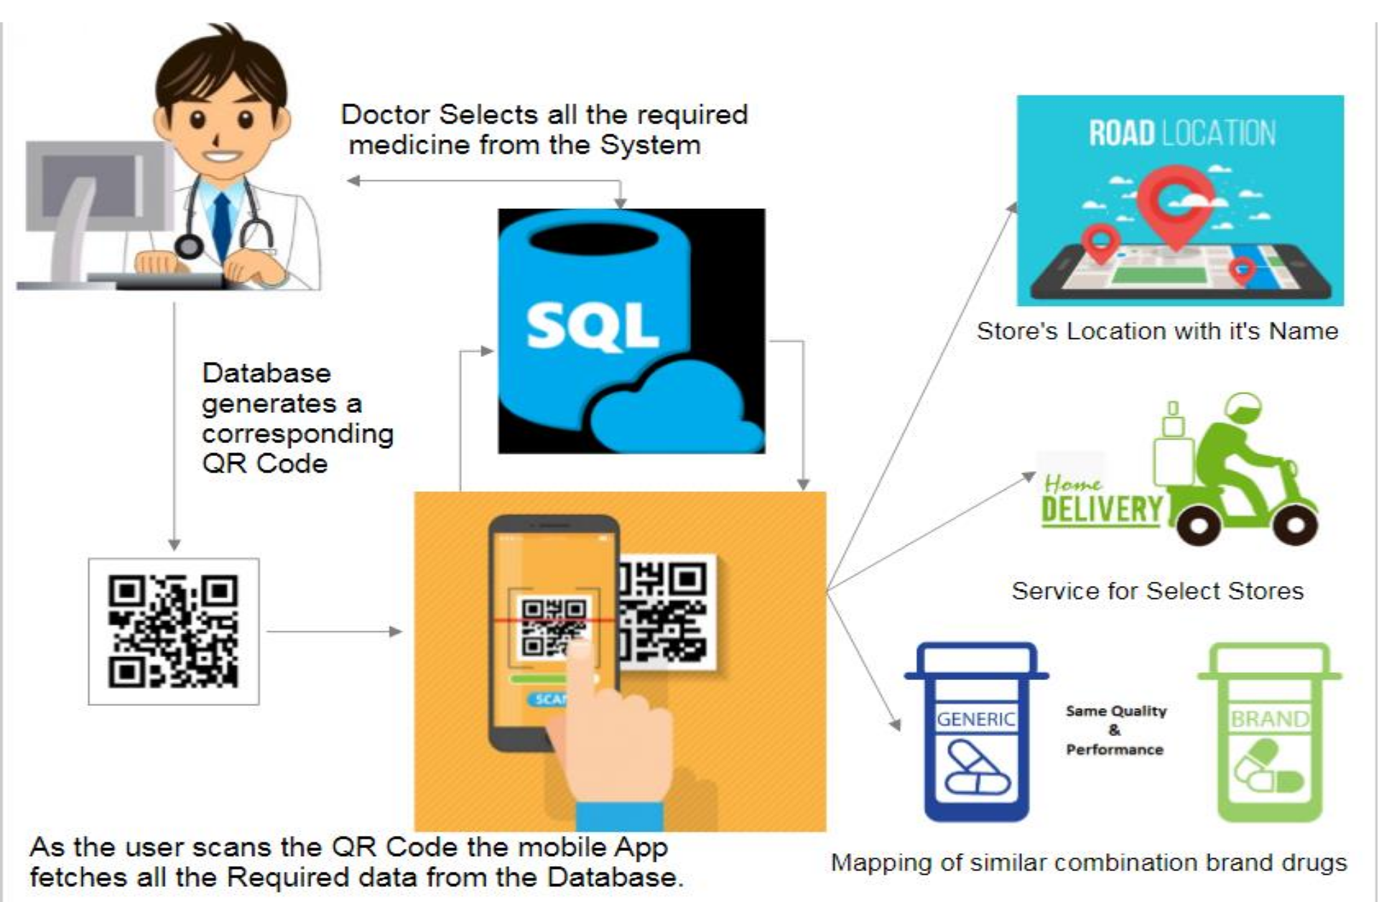





2

3

› A Database of all kinds of medicines, the stores where each drug is supplied and alternatives of each drug(if available of different brand) and list of medical stores providing home delivery service is mDatabase.

Sample Technology Stack

Tech

ological

HTML5



















•Frontend

CSS3

•Frontend

JavaScript

•Frontend

PHP

•Backend

MySQL

•Database

Adobe

PhoneGap

stack

•Mobile

Misc.

•JSON

•Google Maps API

Sample Use Case

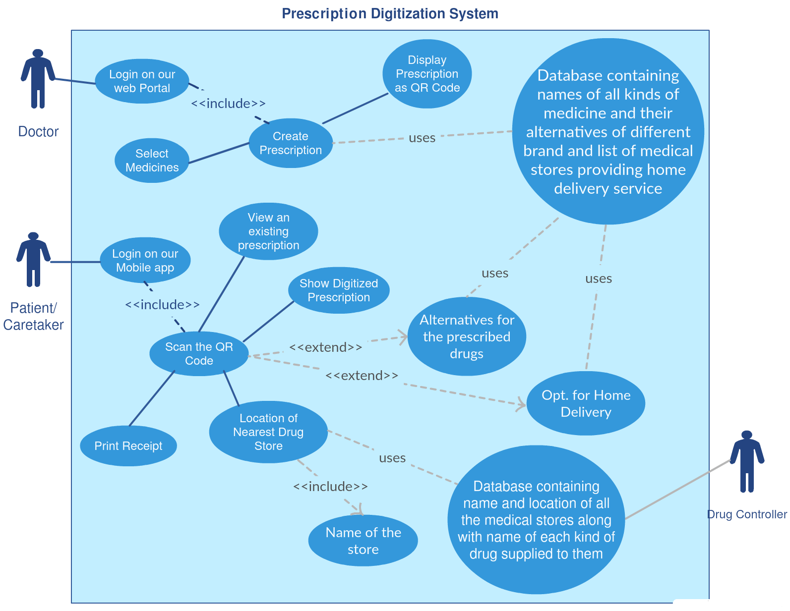

Sample Dependencies / Show stopper



Due to large volume of data, initially a sample size can be determined and taken to calculate the match Sample Data Required.

Our Solution will require list all the medicines currently available in the market, information about their different brand alternatives and names of the stores where these drugs are supplied based on the license issued by the drug controller.

Our Solution will depend on the databases maintained by the drug controller when implemented on a large scale.

Sample Conclusion

This Can potentially help patients adhere with the treatment in case they fail to carry their medicines.